INDIVIDUAL REPORT  
  
 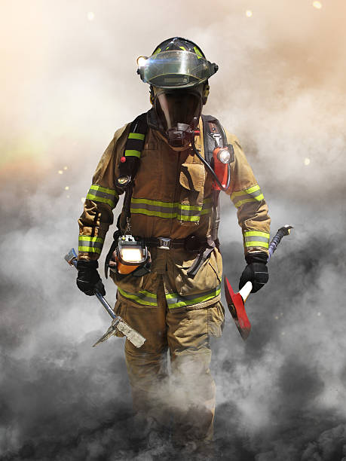

Fire-Fighter Dashboard Application

Aakash Chitroda  
SJSU ID: 013755040  
aakashvrajlal.chitroda@sjsu.edu

Table of Contents

Introduction 1

Related Work 3

The Innovation Design 4

Technical Discussion And R&D 5

Results, Experimentation and Evaluation 6

Conclusion 8

Readme 9

References 9

# Introduction

In its Research Roadmap for Smart Fire Fighting Summary Report, the National Institute of Standards and Technology (NIST) predicts that in the future, new and emerging technologies will usher in the evolution of “smart firefighting” in which firefighters will have a whole new arsenal of tools to work with, such as: data-driven, science-based tactic, information-rich decision making, devices that provide for better situational awareness, comprehensive data collection, analysis, and communication in real time, interconnected buildings and equipment to provide better monitoring, data, and control systems, the ability to use devices to perform functions that humans cannot do. The proposed product - Firefighter dashboard shall be used for the firefighter’s safety and precautions can be taken against dangerous hazards. The present invention relates to sensor data monitoring which provides an automated alarm system for monitoring multiple parameters during firefighting activities and providing appropriate instructions or indications to a firefighter to inform him of a dangerous situation. The aim of this project is to get all the telemetry data of the firefighter team members and send it to the team lead either using serial communication/network protocol. The product being developed for the firefighters and their team members, keeping their requirements in mind the major market segment of the product aims to be Fire Department, but it can be extended to various communities, military and sport adventurous groups, by adding or subtracting some sensor controllers as per their requirements. In the current scenario, firefighters are not embedded with any sensor device and most of the time, firefighters must restore to manual methods of raising the alarm when they are exposed to dangerous environmental situations. These firefighters are covered with thick insulating uniforms which gives them little to no indication about the temperatures rising above the dangerous limits, the heat may get accumulated in these uniforms without any warning to the firefighters, adding further risk to their lives. Hence it becomes difficult to keep track of all the firefighters by the team lead or the firefighter marshal, so with the help of this product, the team lead, or the firefighter marshal shall be able to monitor the firefighter’s health, position and their surrounding areas. As this product is initially targeted for local firefighter department, so after completion of the product, this prototype will be experimented to monitor the product’s efficiency, we can expand the domain to medical applications where blood pressure sensor, sensor to measure glucose, etc can be integrated and monitored by the doctors. Here is our system level block diagram

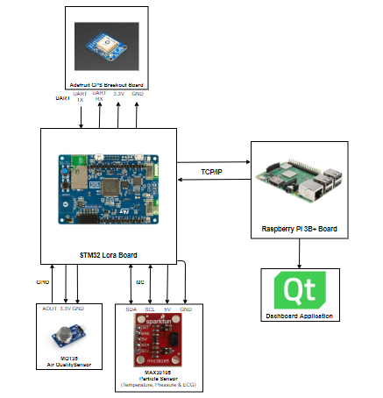

## Related Work

The existing competitive technology allows firefighters to carry the wearable device and an additional walkie-talkie. Sometimes carrying this additional device may seem difficult to manage during the extreme fire situations. To avoid this shortcoming, our proposed product shall implement a built-in push-to-talk feature, which will prevent the firefighters to carry an additional device. This feature will help firefighters to talk to each other and firefighter marshal at ease. Another technological hurdle that these current states of the art products have includes lack of providing the position of the firefighters. Our proposed product will help the firefighter marshal to monitor the GPS coordinates of the team and accordingly provide the instructions to those who are stuck in dangerous surroundings using push-to-talk service. The GPS coordinates can also be monitored over dashboard in real time by the marshal, who guides other firefighters about the whereabouts of each other. In the worst-case scenario, if the firefighter stops responding or acknowledging, the firefighter marshal can summon a rescue team for the firefighter in danger based on their GPS coordinates in real time scenario. Our proposed product involved interfacing STM32 board with Raspberry Pi 3 B+, implementing a push-to-talk service using Raspberry Pi and designing interactive GUI considering QT framework as a platform. Due to such a low scale implementation, our total product cost shall be less than the existing market products. In case of any pitfall in the device, the faulty controllers and sensor modules are easily replaceable aiding low and easy product maintenance. After successful completion of this product, the firefighting team lead could monitor the telemetry data and accordingly provide instructions to its team members using push-to-talk service preventing any life casualty/injury.

## The Innovation Design

In this section, I would like to brief you about my role and responsibility as a team member contributing to the project. My main focus on this project was

* Entire development on raspberry pi was looked by me.
* To design and develop Graphical User Interface to display the health-related information of a particular firefighter.
* One innovative thing I developed was to send and receive real time audio data and output it to the user so that he/ she can listen to that audio in real time.
* Send and receive sensor data from STM discovery board over Wi-Fi using UDP protocol which is faster.
* Once data is received, need to locally log the data in a text file. This was achieved with no efforts.
* Also, one of the key things was to connect Bluetooth headphone with raspberry pi and record data using the Bluetooth headphone.
* Apart from this, I also successfully interfaced SIM7000A module with raspberry pi using USB interface. With this module I was able to successfully read the GPS data using AT commands using UART protocol and simultaneously logging the data in a text file.
* One of the big things was to bypass data through the LTE module to make it Wi-Fi independent.

Working on this project was a rewarding experience and there were certain challenges which I faced while doing the design and development and with the right approach, I was able to overcome.

Here are the technical challenges which I faced while working on this project.

* Connecting Bluetooth headphone to raspberry pi. It is easier to connect your Bluetooth headphone to your smartphone and make it as a default device for input and output. But its challenging to connect the same with the embedded devices like raspberry pi. So to overcome this I had to install certain dependency on embedded linux machine called BlueZ which is Bluetooth Stack. BlueZ deals with pure Bluetooth tasks like pairing and connecting to the headset. Also, BlueZ needs additional SW components for audio management called bluetoothctl which is used for pairing and connecting to the headset. In the backend BlueZ is running the Bluetooth tasks. [1]
* Recording audio through Qt application and send the real time data over UDP without noise. For this Qt provides their customer with the library called QAudioInput and QAudioOutput. I had to bind my UDP to separate port for this feature which was interrupt based. Further to send and receive audio data without noise, I had to implement a low pass noise filter algorithm which removes noise from each and every byte. This is the first level of filter which is most commonly used. [4]
* In near future, we can display the graphs for temperature, air quality, heart rate on GUI using Qt. This is one of the challenging things for the developer. Earlier Qt version did not have any libraries to plot graph. So, the user had to download third party library to plot graph. But in their recent release version, they are providing the user with their own set of libraries to plot graphs.
* Key challenge while working for actual firefighter project was to interface LTE module with raspberry pi using USB interface. To start interfacing, I had to install the USB drivers of LTE module first. Once driver is installed, I started LTE connection with the LTE module using UART application. Reading the LTE module datasheet tells us which command we need to send. Once the LTE connection is up, next step is to bypass traffic through the module to make raspberry pi Wi-Fi independent. For this we have to perhaps optimize certain files at the system level and the start the connection using qmi services. [2][3]

## Technical Discussion And R&D

Key objective of our project was to monitor health related data of a firefighter. The fighters who risk their life to safe others, so it becomes our responsibility to develop such device which at least gives the data related to their health when they are on duty. Considering this aspect, we came up with this project which will monitor health related data and provide real time audio sending and receiving features to easily communicate with them. In past, we have had many incidents where firefighter had suffered injuries or even died while extinguishing fire because of sudden increase in heart rate or due to very high flame temperature or bad air quality. To avoid this shortcoming, our proposed project would monitor all the necessary health related parameter which will be sent over air via UDP (cloud in near future). All the components in our project plays crucial role when it comes to safety. Various sensor devices give us the air quality, heartrate, temperature and GPS data which are very crucial. A simple but dynamic GUI which monitors all the parameters. A PTT service (Push to Talk) which can be very handy when it comes to fast and reliable communication. This feature will help firefighters to talk to each other and firefighter marshal at ease. Another technological hurdle that these current states of the art products have includes lack of providing the position of the firefighters. Our proposed product will help the firefighter marshal to monitor the GPS coordinates of the team and accordingly provide the instructions to those who are stuck in dangerous surroundings using push-to-talk service. The GPS coordinates can also be monitored over dashboard in real time by the marshal, who guides other firefighters about the whereabouts of each other. In the worst-case scenario, if the firefighter stops responding or acknowledging, the firefighter marshal can summon a rescue team for the firefighter in danger based on their GPS coordinates in real time scenario.

1. STM discover board is one of the key components in which all the sensors are interfaced. It reads value from each and every sensor using FreeRTOS.
2. Establish connection with Wi-Fi device.
3. Open a UDP port and send the data to the host IP address and port.
4. Receive the real time audio and output it to the headset.
5. Embedded device like raspberry pi is used to monitor the telemetry data of the firefighter.
6. For monitoring data, a simple yet dynamic GUI is designed and developed using Qt framework.
7. In the backend, receive the telemetry data by binding the UDP to a specific port.
8. Parse the incoming data into a structure.
9. Display the structure values on GUI.
10. Give a button to record and send data using UDP to the STM discovery development board which is real time audio.

## Results, Experimentation and Evaluation

Here are some of the images which shows the setup and screenshots of output which we captured before our final demo

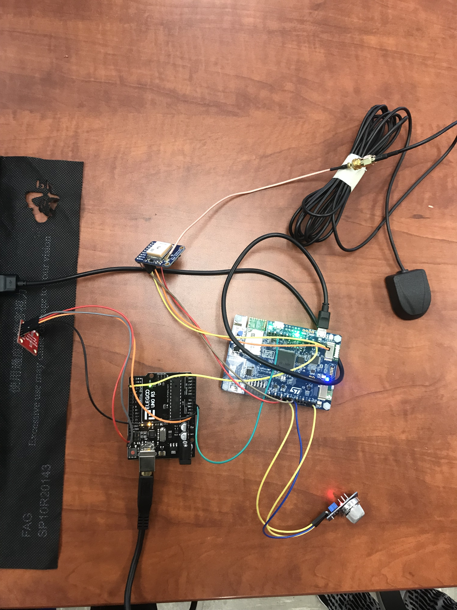

Fig 1. Set up of ST discovery board with all sensors interfaced.

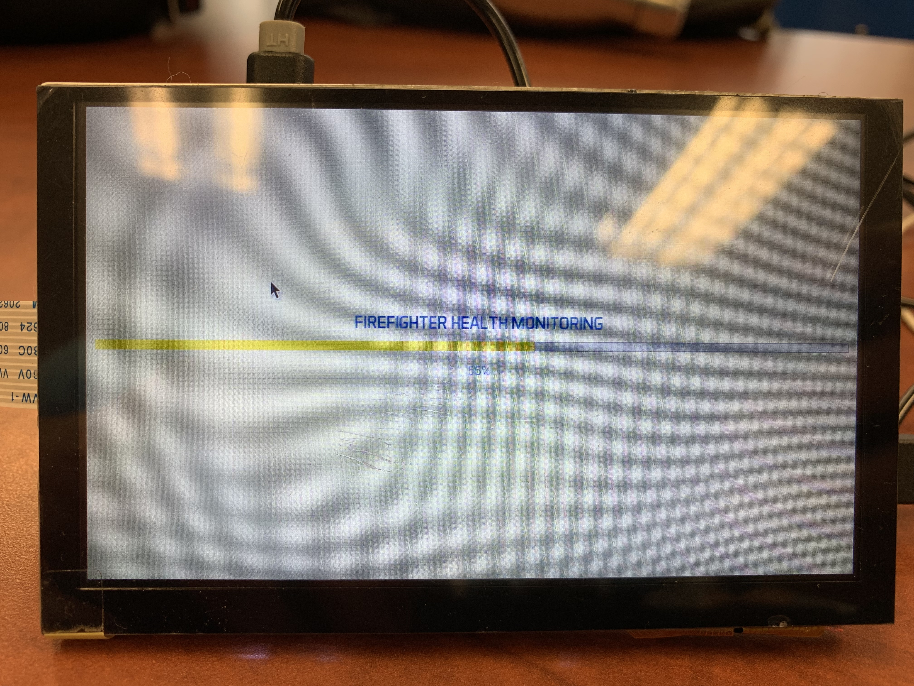

Fig 2. Set up of raspberry pi using 5inch TFT DSI display.

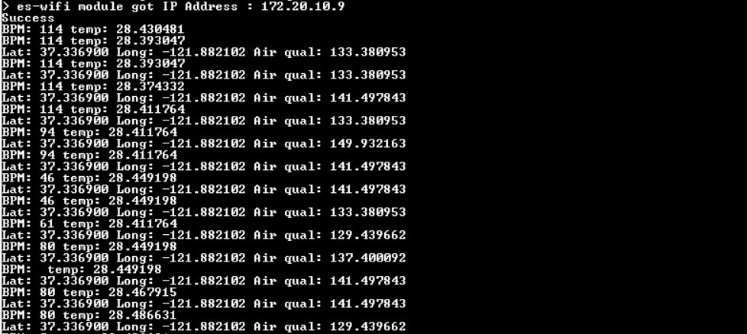

Fig 3. Terminal output of sensors interfaced with STM discovery board.

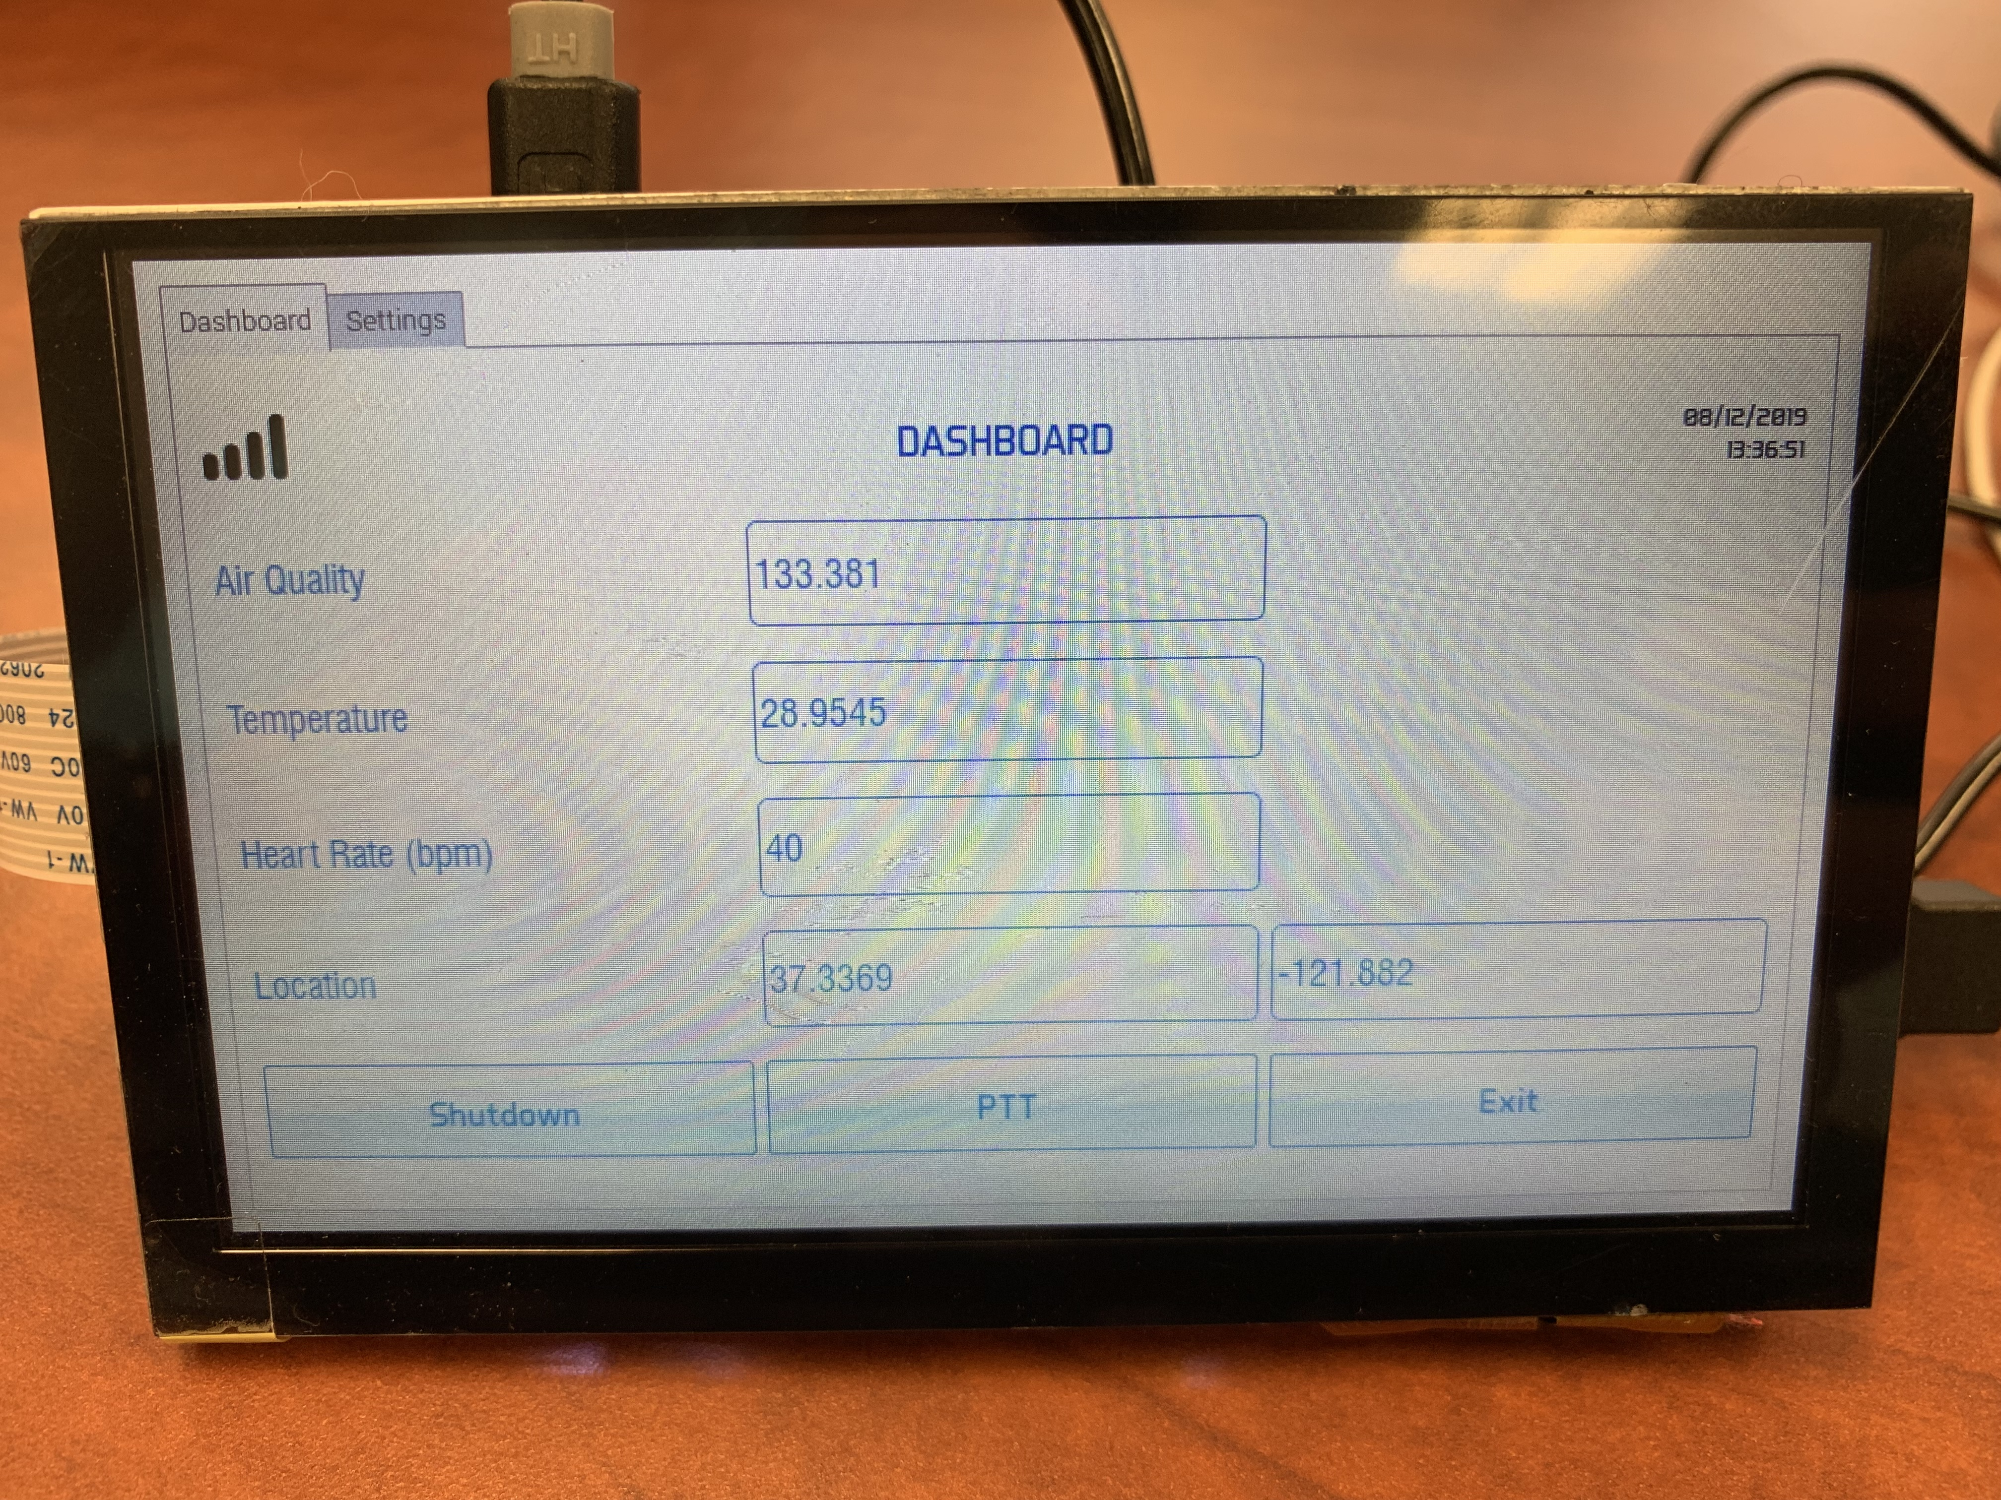

Fig 4. Monitoring sensor values on raspberry pi using Qt framework

## Conclusion

Safety of firefighters is our priority. Firefighter dashboard shall be used for the firefighter’s safety and precautions can be taken against dangerous hazards. Our invention relates to sensor data monitoring which provides an automated alarm system for monitoring multiple parameters during firefighting activities and providing appropriate instructions or indications to a firefighter to inform him of a dangerous situation. The aim of this project is to get all the telemetry data of the firefighter team members and send it to the team lead either using serial communication/network protocol. The product being developed for the firefighters and their team members, keeping their requirements in mind the major market segment of the product aims to be Fire Department. Not only Fire Department, but also our product can be extended to various communities like military and sports adventurous groups by adding or subtracting some controllers as per their requirements. Our product is featured to provide real-time location facility because of which firefighter marshal will be able to monitor all its team members location. Moving on, our vision has been successfully implemented using various sensors like temperature, heartbeat sensor, and air quality sensor. After successful completion of this product, the firefighting team lead could monitor the telemetry data and accordingly provide instructions to its team members using push-to-talk service preventing any life casualty/injury.

## Readme

<https://drive.google.com/drive/u/1/folders/0ALOTuxiOtuoxUk9PVA>

## References

[1] Setting up BlueZ: <http://youness.net/raspberry-pi/bluetooth-headset-raspberry-pi>

[2] Connecting to a network: <https://github.com/botletics/SIM7000-LTE-Shield/wiki/Connecting-to-Network>

[3] LTE drivers installation: <https://github.com/botletics/SIM7000-LTE-Shield/issues/15>

[4] Qt Audio Recording Sample: <https://doc.qt.io/archives/qt-5.5/qtmultimedia-audiorecorder-example.html>